Professor Paul Roy 1939-2014
The establishment of the Department of Nephrology and the Centre for Kidney Research at the Royal Alexandra Hospital for Children in Sydney
Joyce, Simon and Jane Roy
January 4, 2017
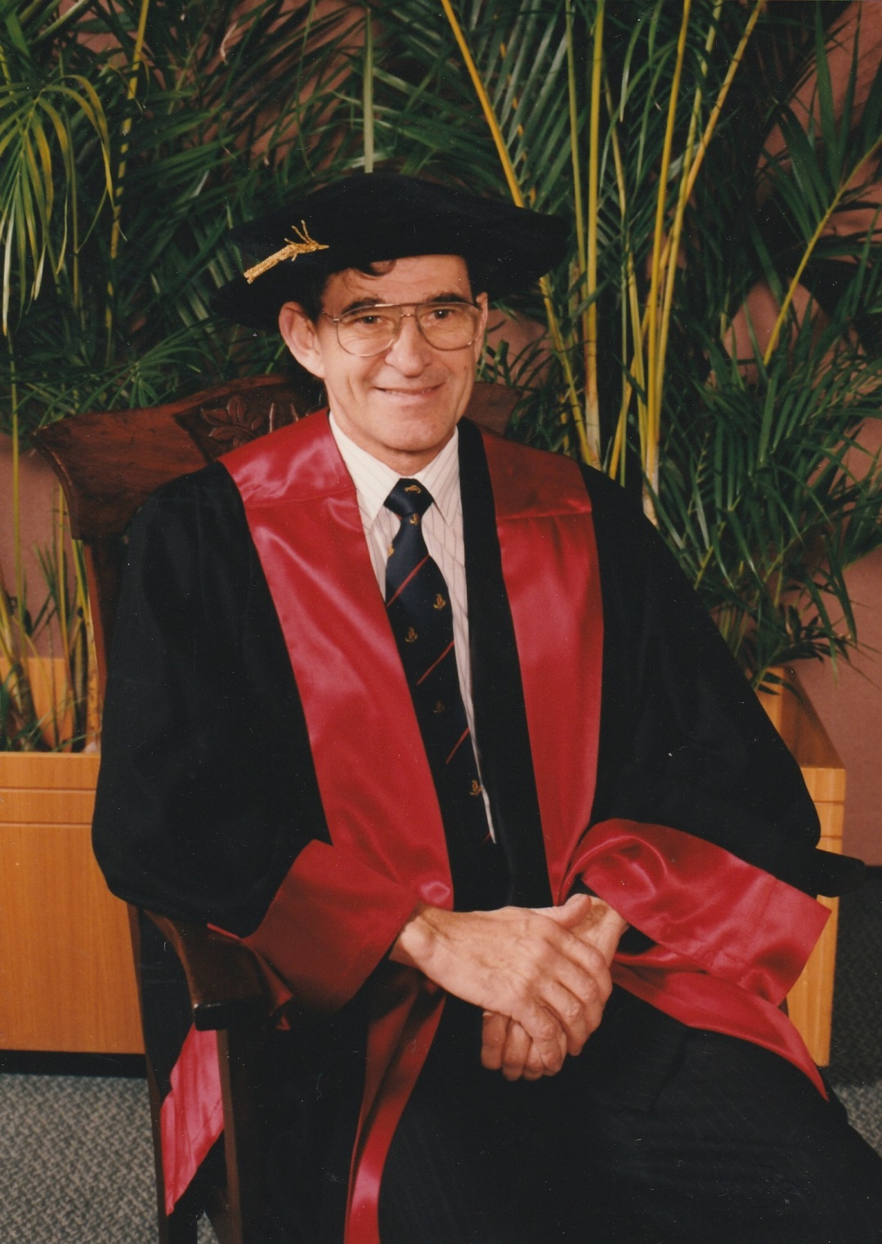
Professor Paul Roy at the Royal Australasian College of Physicians in 1995
At a time when specialist paediatrics barely existed in Australia and overcoming strong opposition from many in the medical establishment and government in NSW, Professor Paul Roy founded the Department of Nephrology at the Royal Alexandra Hospital for Children at Camperdown (RAHC) in Sydney.
Between 1964 and 1965, Professor Roy was a Registered Medical Officer (RMO) at Royal Prince Alfred Hospital (RPAH) in Sydney. In his second year, after being shown the technique of peritoneal dialysis using a “hard” catheter and being invited to accompany the then Chief Resident to perform a kidney biopsy at RAHC, his interest in paediatric kidney disease began. He was an RMO at RAHC between 1966 and 1967 and performed peritoneal dialysis on a 15 month child with acute haemolytic uraemic syndrome, a condition usually fatal at that time. The child survived and was well at age 15 when the family moved to Queensland.
On completion of his paediatric training in 1968, Professor Roy was appointed Clinical Superintendent at RAHC and prepared a proposal for the establishment of facilities for a Department of Nephrology including dialysis and transplant at the hospital. This was supported by Dr Phil McReady, then General Superintendent and by the Honorary Medical Physicians (there were no staff specialists then) as well as others on the Hospital Board. In 1969 the hospital arranged for Professor Roy to attend the 4th International Congress of Nephrology in Stockholm, where he presented a paper and he became a member of the International Society of Nephrology. Before returning to Sydney he visited a number of paediatric kidney units in the United Kingdom and the United States of America to learn more about how a Department of Nephrology might be set up in Sydney. Paediatric Nephrology had become established as a separate paediatric specialty in the 1960s in Europe and North America.
On a research grant obtained from the Post Graduate Medical Foundation Professor Roy went to train in clinical nephrology and kidney research at the University of Minnesota under the supervision of Dr Alfred Michael and Dr Robert Vernier between 1970 and 1972. Before returning to Sydney he submitted a protocol outlining the most basic equipment needed to set up a nephrology department at RAHC. This included a technician to assist with research, a part time registrar, basic office space and access to centrifuges, microscopes for immunofluorescent and electron microscopy studies and beds in a ward for patients. Professor Roy reported on the immunofluorescent studies and electron micrographs of kidney biopsies throughout his nephrology career. However Professor Roy faced considerable opposition to setting up a department from the new leadership of RAHC and from adult nephrologists.
Nevertheless Professor Roy was eventually allocated two beds for kidney patients in Hall Ward at RAHC. In 1973 Professor Roy commenced haemodialysis treatments and kidney transplants for children at Royal Prince Alfred Hospital (RPAH). These procedures continued at RPAH until the move to Westmead in 1995. In 1978 the Sydney Morning Herald’s medical reporter, Shaun McIlraith, praised the work of Professor Roy with an article titled “Kidney Research gives hope to the Young” and this became a turning point in the establishment of the Department of Nephrology at RAHC. Sir Lorimer Dodds, the first Professor of Child Health in Australia, wrote to him praising his work and stating that “in [my] time renal failure in infancy and childhood meant nothing more than a progressive and unrelenting fatal illness”
Between 1973 and 1988, 65 children with end stage kidney failure (ESKD) were treated with dialysis and transplantation by Professor Roy and his colleagues. Professor Roy was the only consultant until 1979 and there were no specially trained renal nurses until 1981. Until 1978 all children received haemodialysis. From 1978 peritoneal dialysis became the treatment of choice for children with ESKD. Professor Roy introduced intermittent peritoneal dialysis to RAHC in 1978 and then continuous ambulatory peritoneal dialysis in 1981. This necessitated the appointment and training of nurses, who specialised in dialysis. At first Professor Roy carried out the surgical procedures for haemodialysis access (A-V fistulae) and peritoneal dialysis though he had handed over these procedures to surgical colleagues by the late 1980s.
In 1980 Mr J.T. Honan, Head of Manildra Holdings expressed interest in Professor Roy’s work and began raising much needed funds for kidney research. He has continued to generously support the unit. In 1980 Professor Roy, with the assistance of Dr John Knight, began setting up the research unit, which became the Centre for Kidney Research. One of Professor Roy’s most important research projects was to establish the methodology to measure cystine levels in children with cystinosis. This Centre now run by Professor Stephen Alexander (laboratory research) and Professor Jonathan Craig (clinical and epidemiological research) is recognised internationally.
From the inception of the Department of Nephrology Professor Roy introduced multidisciplinary care (then a new concept) to the Department with dieticians, social workers, occupational therapists, play therapists, psychologists and psychiatrists as well as nurses and doctors being involved in the children’s care. When he was appointed as Head of the Department of Medicine, Professor Roy extended this practice into all medical wards. It had a profound effect in bringing all staff together to discuss problems and issues encountered and how best to deal with them.
Apart from his speciality as a kidney physician Professor Roy had a deep interest and great knowledge in general paediatrics. He was actively involved in research all his life publishing over a 100 papers. Of most importance was his survey of blood pressures in 10,000 school children to provide data on normal blood pressures in Australian children. Professor Roy consolidated this work for submission as his MD thesis after he retired. He received numerous awards including the RACP Medal for his work with the Royal Australian College of Physicians (RACP), was given life time Membership of the US Kidney Foundation and other organisations, was active in many committees, teaching at the University of Sydney, RPAH, and teaching and examining with the RACP, the Australian Medical Council and overseas institutions. He was also the Australian representative for about eight years on the Council of the International Pediatric Nephrology Association taking over from Dr David McCredie in 1983.
When RAHC moved to Westmead, Professor Roy was appointed Director of Paediatric Services for what is now Sydney Local Health District, but he remained a member of the Department of Nephrology at the Children’s Hospital at Westmead as a clinician and as researcher. He was a principal investigator of clinical studies of urinary tract infection of kidney (the PRIVENT study) and of kidney and heart health in aboriginal children (the ARDAC study); both studies were funded by the NHMRC.
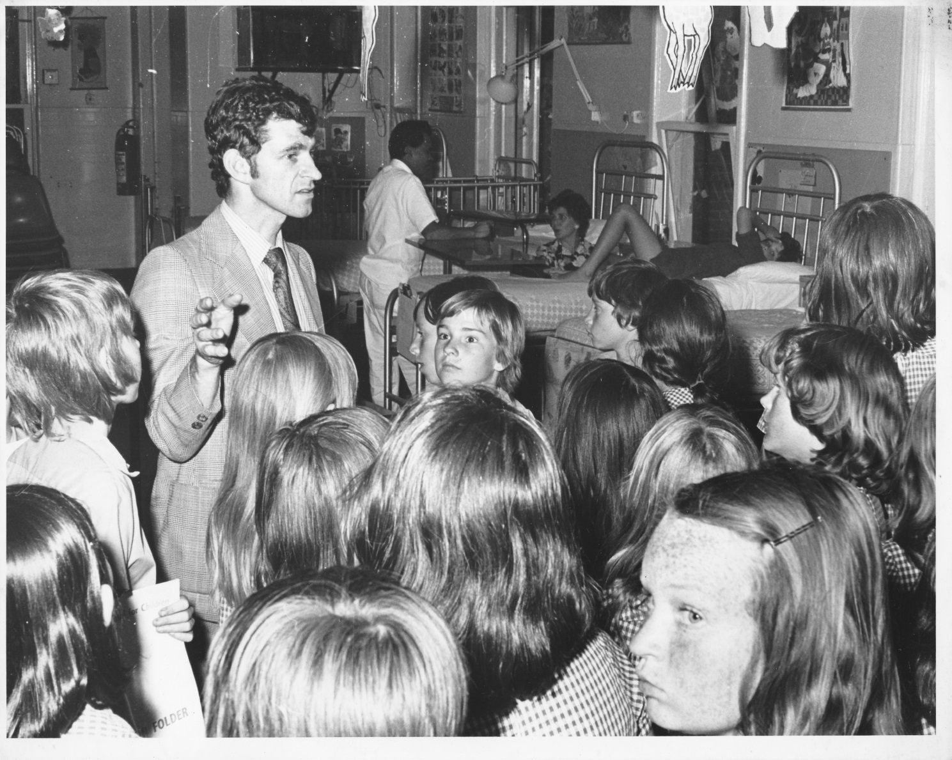
Paul Roy showing school children around a ward at the Royal Alexandra Hospital for Children in Camperdown in 1976

