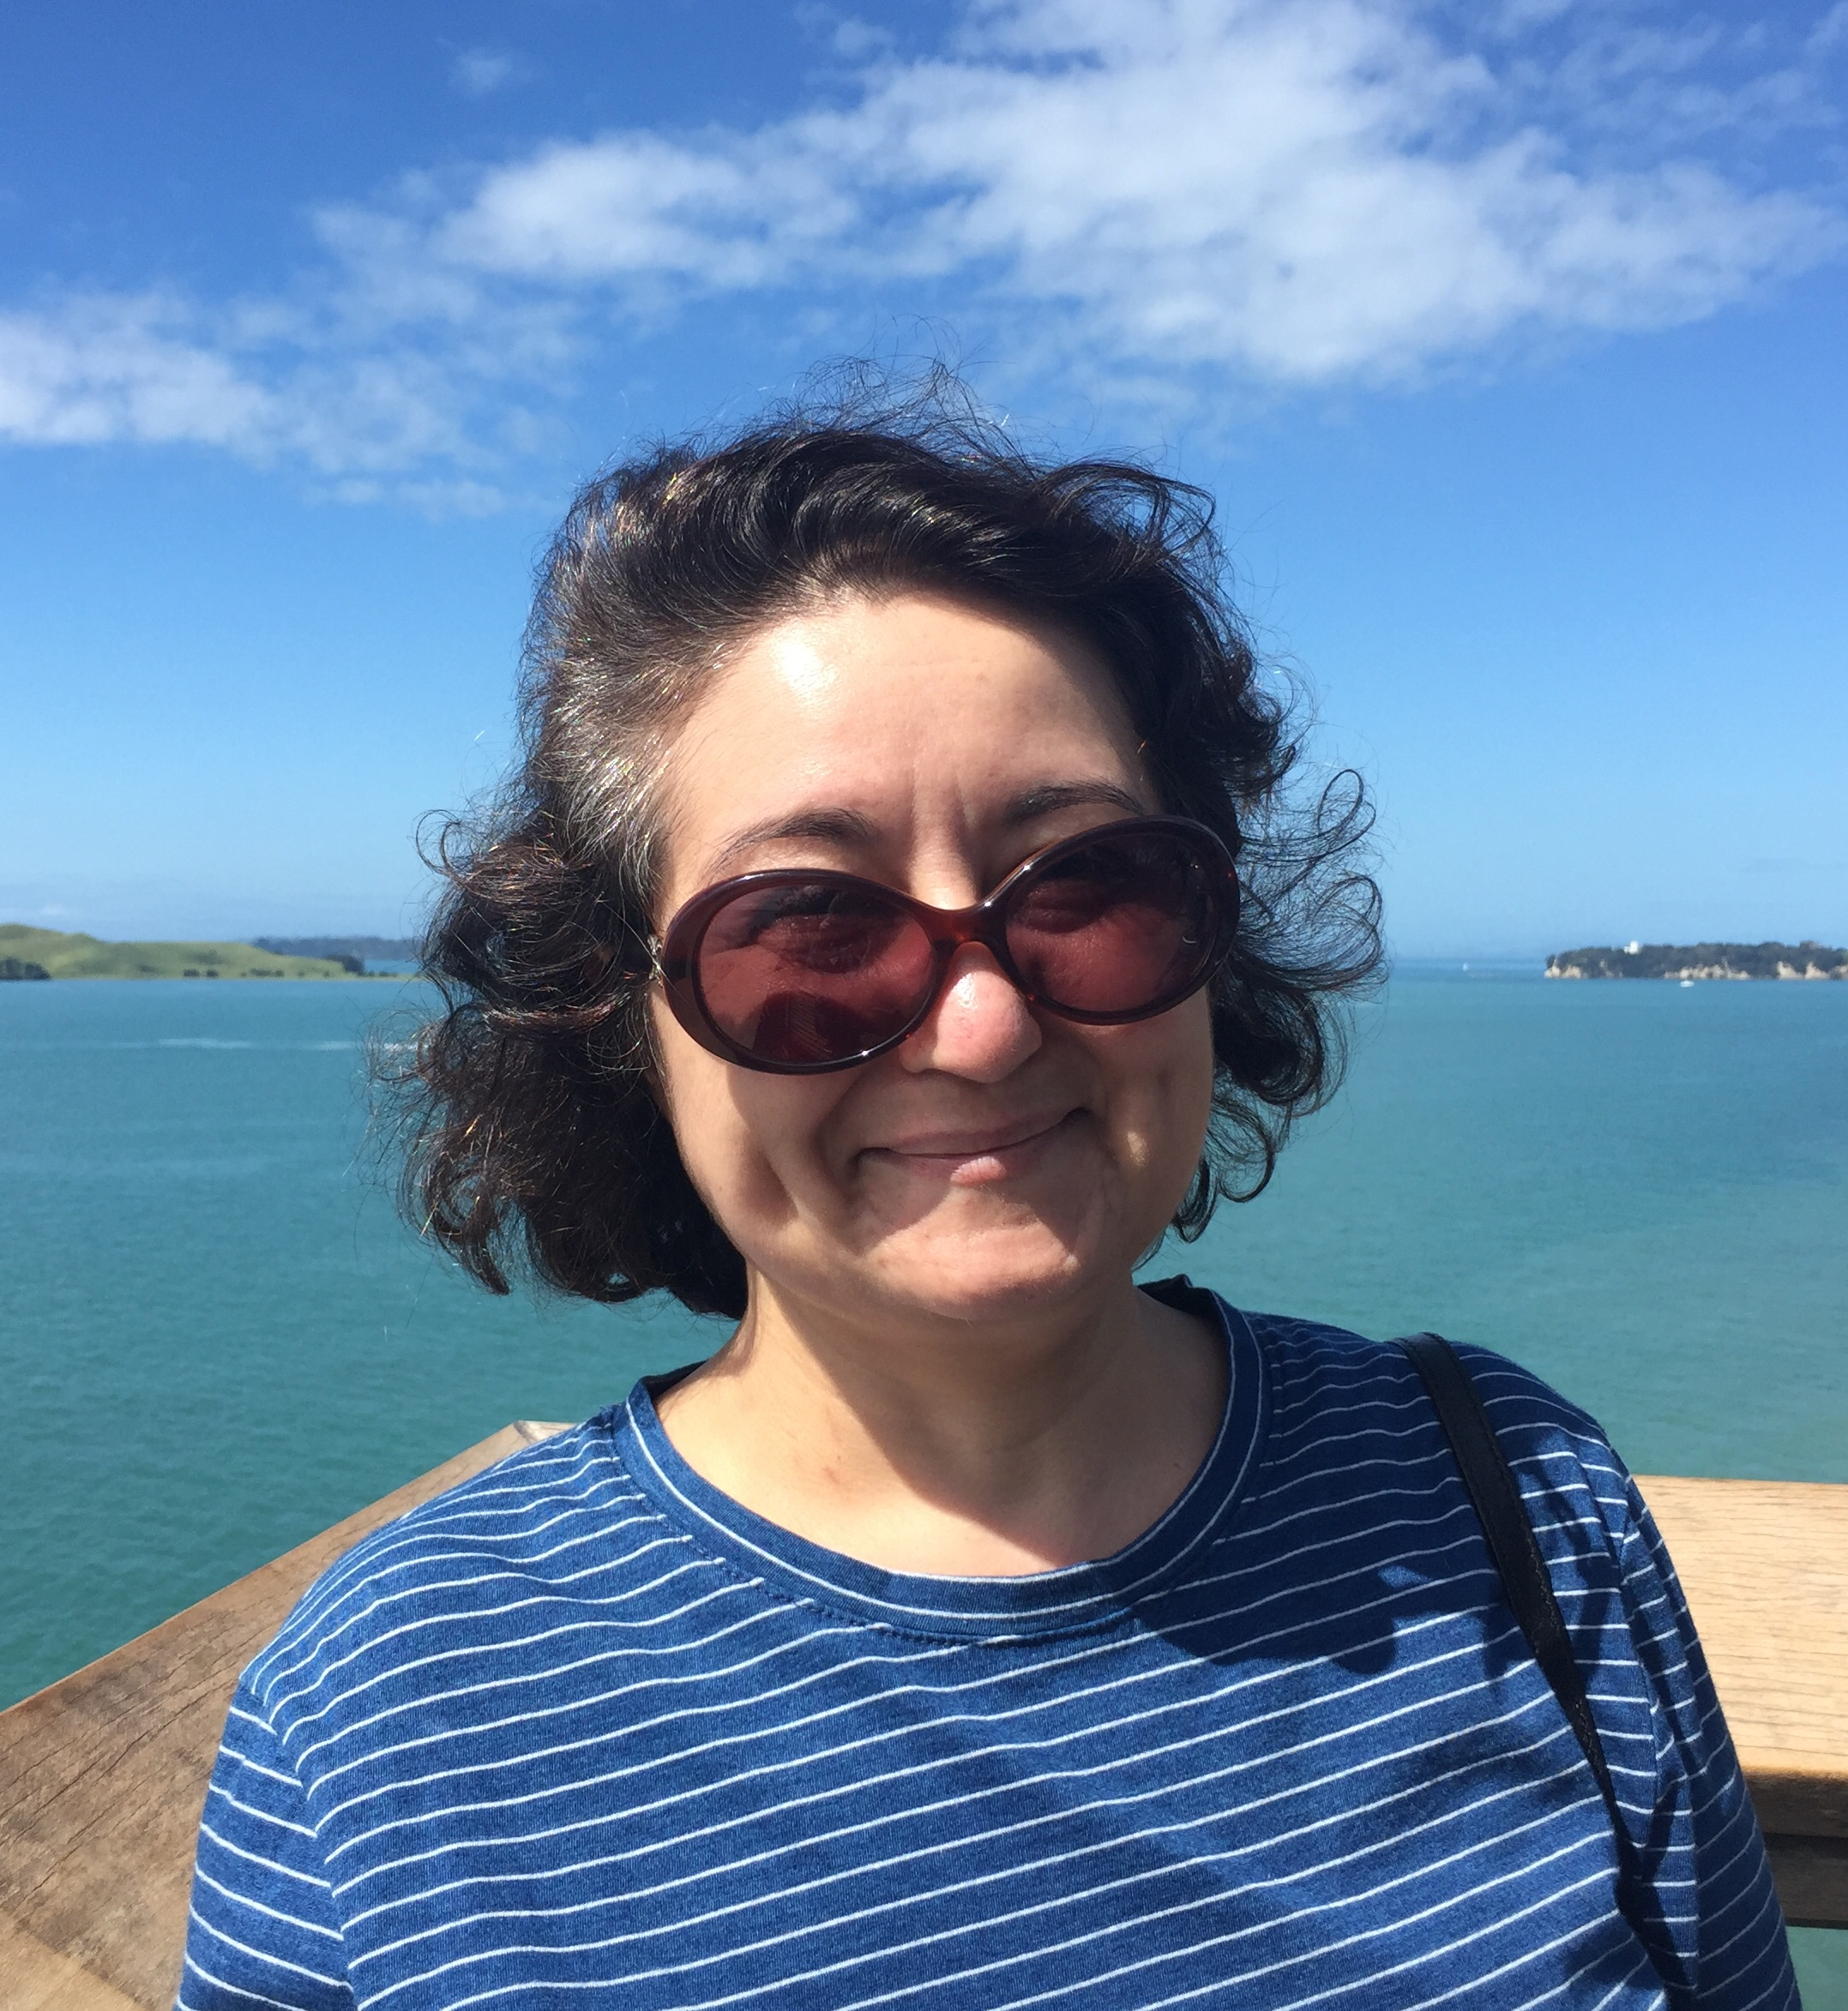

On 22 January 2018, we – patients and families, paediatric and nephrology staff across NZ, and the wider paediatric and nephrology community particularly in Australia sadly lost a true friend and dedicated colleague. Tonya passed away peacefully in the company of her sister and friends after a diagnosis of cancer just a few short months earlier.

Tonya was adamant that she not be referred to as brave but she certainly faced her illness with strength and stoicism. She was able to enjoy the festive season with her family who visited from the UK and she enjoyed some lovely trips showing them New Zealand. She certainly retained her acute intellect, dry sense of humour and impressive online shopping skills throughout her illness.

Tonya had a wealth of professional experience from her work in the UK, Australia, Canada and New Zealand alongside an incredible life story with family living in Africa and Pakistan.
Tonya was heavily involved the Royal Australasian College of Physicians and spent hours tirelessly supporting paediatric registrars through their exams and examining, including being Chief Examiner for NZ for a number of years. She was a superb teacher and mentor, leaving an extensive legacy of paediatricians across New Zealand who can’t thank her enough for her care and support, pep talks and clinical teaching to get through exams, bad hair days, fashion faux pas, career indecision and personal dramas.

She was a highly productive member of the nephrology community, and involved in many working groups and committees including the National Renal Advisory Board, National Renal Transplant Leadership Group, ANDATA and ANZPNA – ultimately in pursuit of her passion to advocate for better patient care and outcomes. We actually had no idea how many various committees, projects and collaborations she was involved with until now and it’s certainly a challenge trying to in some way step into those shoes in her memory.

She absolutely loved all those she cared for, and her patients and their families returned the love and attention she gave them. As although she didn’t share her illness with them, throughout her career she had accumulated more thankyou cards, letters and art works from patients than we are sure anyone could trump. Her office was the most colourful and decorated in Starship.

Tonya will leave an irreplaceable void in our community, but we celebrate her life, her professional contribution and the legacy she has left in both paediatrics and nephrology.

